Year 6- Autumn Curriculum Newsletter 202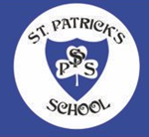4

**Literacy**

The books we will be covering are: Clockwork & Twitch. The genres we will be covering are:

* Persuasive Writing – Healthy Eating & Lifestyles
* Leaflet
* Formal Letter
* Diary entry
* Setting description
* Character description

We also teach:

* Weekly comprehension and grammar lessons
* Daily shared reading lessons

Please remember to read with your child at least three times a week and discuss what they are reading.

**Numeracy**

This term we will be revising and covering:

Integers and decimals

Multiplication and division

Calculation problems

Fractions and decimals

Percentages

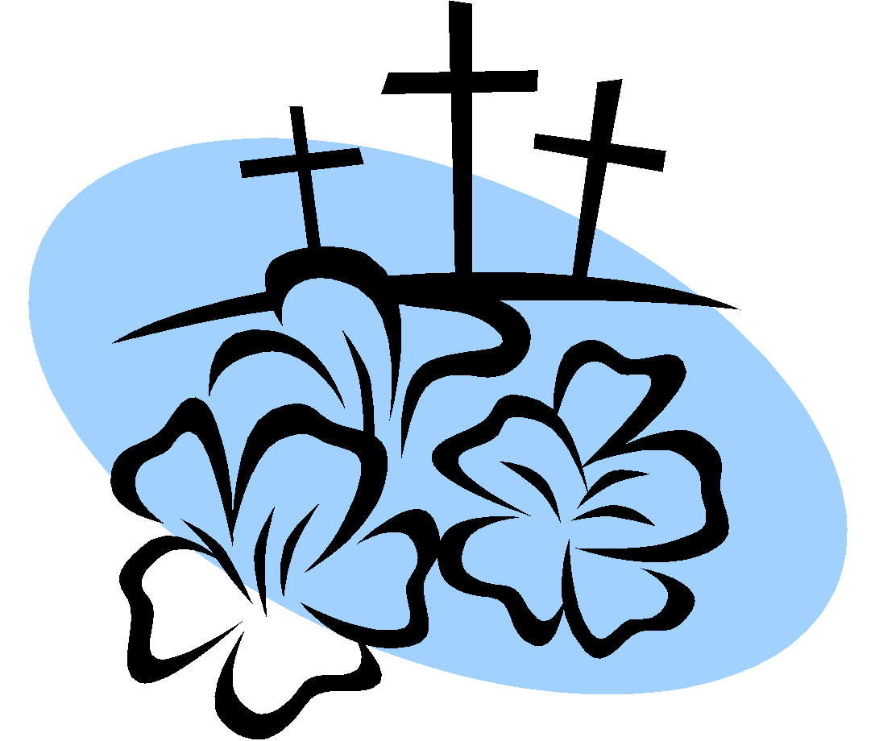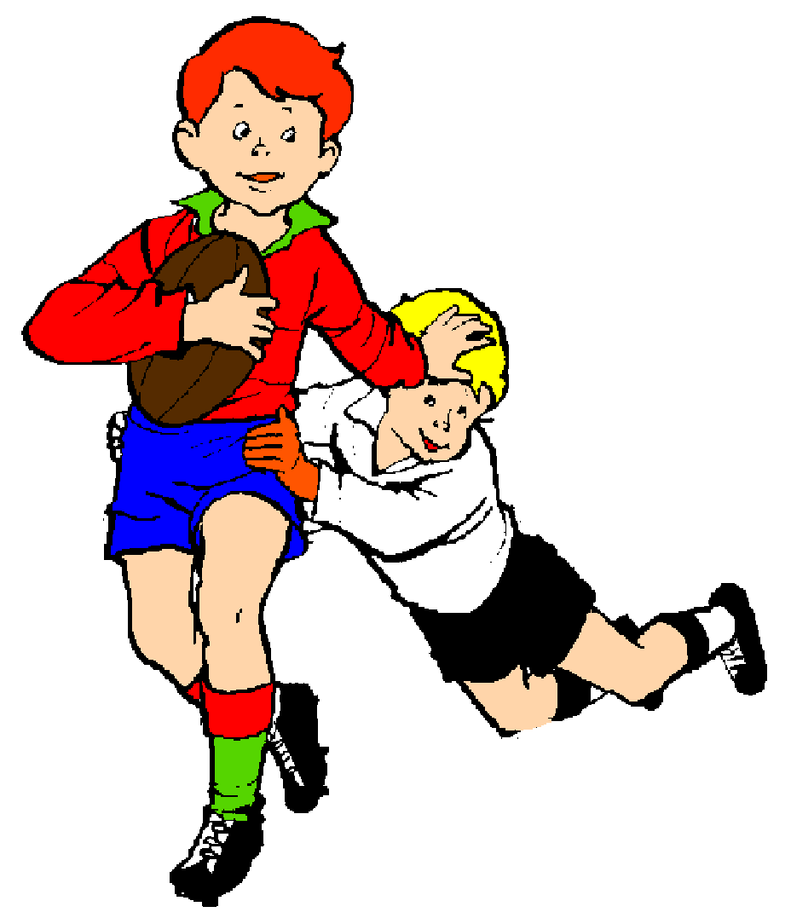00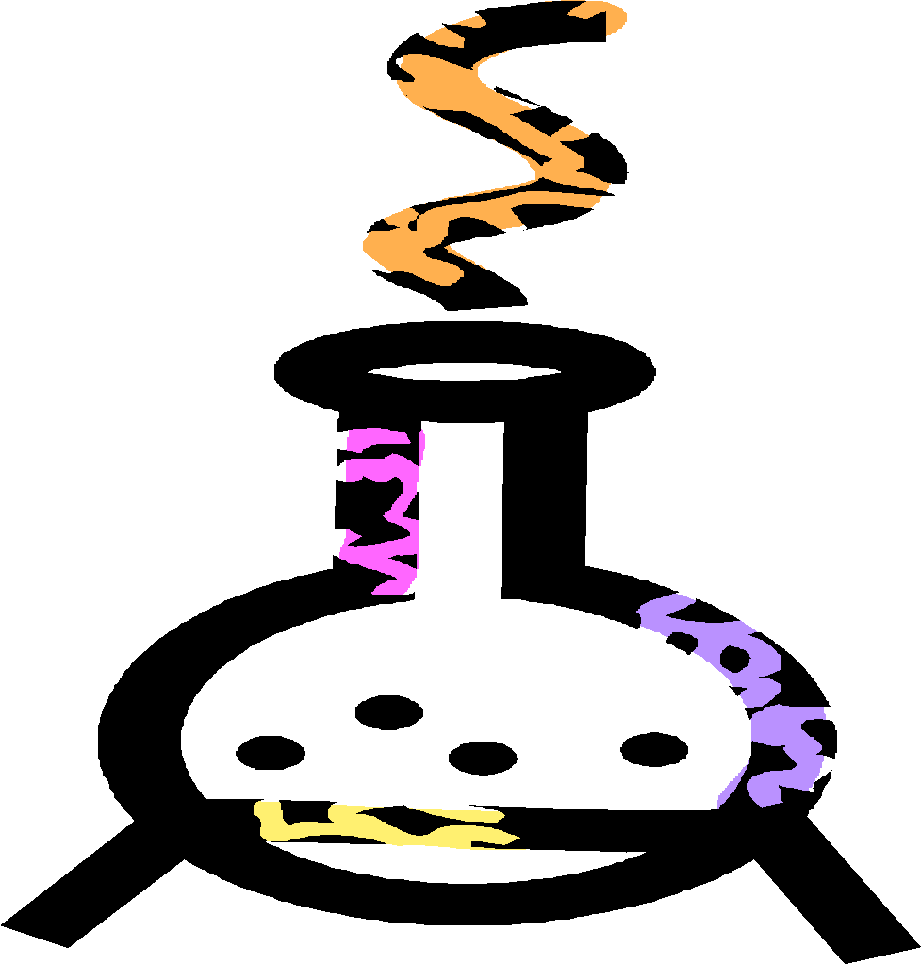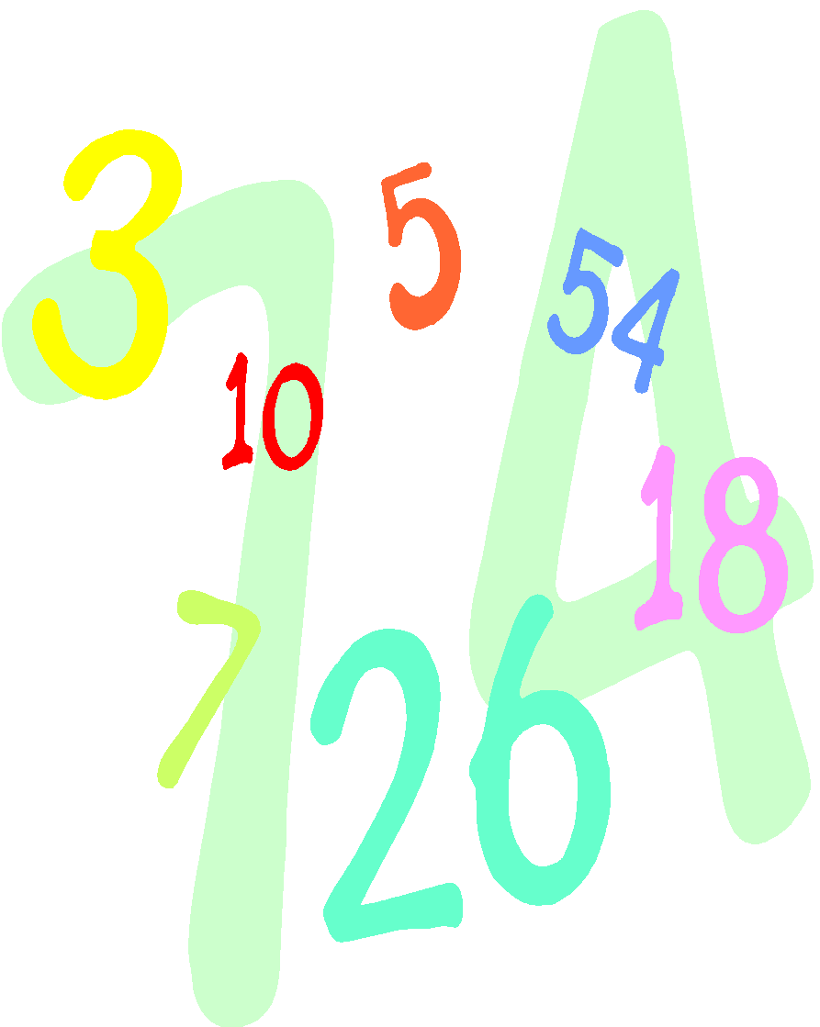

**Notice :** **Please do not use any past SATs papers as revision tools because we use them in school as assessment materials and for teaching resources.**

**Geography**

We will be learning about The Amazon:

* Where is the Amazon?
* What would it be like to walk through the Amazon?
* What is Manaus like?
* Do people live in the Amazon rainforest?
* How can people protect the Amazon?

**History**

We will be studying **The Maya Civilisation:**

Why should we remember the Maya?

**RE**

We will be covering our topic on:

* Loving
* Commitment and Vocation
* Islam
* Judaism
* Advent

Our special writing will be comparing how the nativity is presented in the Gospels of Luke and Matthew.

**Homework**

Weekly spellings – test every **Friday**

Maths

English

**Music** 

Reggae:

* A brief introduction to the history of Reggae.
* Listen and appraise music by Reggae artists
* Learn about key Reggae musical features
* Perform drum patterns

**Art/DT**

We will be investigating textiles and photography.

**PE**

**PE kit must be worn to school every Monday**

Through volleyball and yoga, we will be developing a range of skills including sportsmanship.

**PSHE/Wellbeing**

We will be learning about:

* Class rules
* Composing individual prayer for class prayer book
* Core values
* Catholic Social Teaching Principles
* British Values
* God cares for us and wants us to put our faith in Him.

**Science**

We will be learning about Animals, including humans and Light:

* How blood travels around the body and the other major organs
* How does light travel?
* Reflectivity
* All about shadows