Year 5 - Autumn Curriculum Newsletter 2024

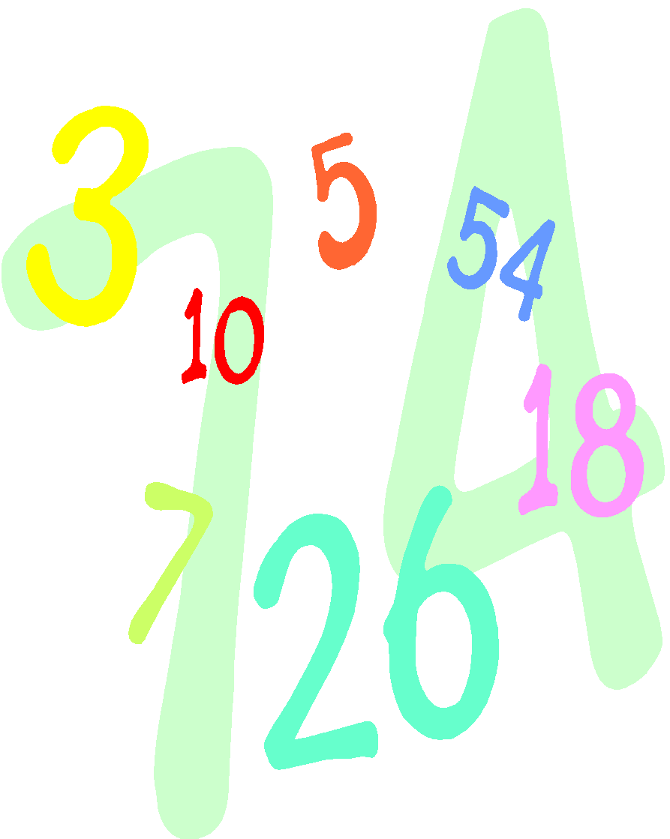

**Numeracy**

Number and Place Value

Roman Numerals

Addition and Subtraction

Line Graphs and Timetables

Multiplication and Division

Area and Perimeter

**Literacy**

The books we are covering are: ‘*The Princess’ Blankets’* and *‘Cosmic’.* We will also be looking at poetry.

The genres we are covering are:

Character and setting descriptions;

Poetry;

Narrative based on a familiar story;

Non-fiction website page;

Retell a chapter from a different perspective

Weekly comprehension lessons

Daily grammar lessons

Weekly spellings

Please remember to read with your child at least three times a week and discuss what they are reading.



**PE**

**PE kit must be worn to school every Thursday**

Swimming – St Blaize

Athletics / Badminton – St Bernadette

Swimming (P5)

**Homework**

Weekly spellings – test every **Friday**

Maths and Grammar Homework - relating to what we have been learning in class to consolidate learning.

Homework due in on **Wednesdays.**

**Music**

Africa: Performing and composing rhythmic pieces of music, percussion instruments)

**French**

Getting to know you and all about me

**History**

The Anglo-Saxons

*Was the Anglo-Saxon period really a Dark Age?*

**Computing**

We Are Game Developers / We are Cryptographers / We Are Responsible For Our Online Actions

**PSHE/Wellbeing**

British Values

Class Rules and Core Values

Created and Loved by God: being calm

Black History Month

Created to Love others: personal relationships, peer pressure

**DT**

Electrical systems: Electronic greeting cards

**Art**

Formal Elements of art: Architecture

**Science**

***Life Cycles***

Life cycles of birds, insects,

mammals, amphibians, reptiles

Life cycles and reproduction in plants.

***Forces***

gravity; air resistance; water resistance; friction; mechanisms (pulleys, levers, gears).

**RE**

We will be learning about:

Ourselves

Life Choices

Other faiths (Islam & Judaism)

Hope (Advent)