Year 3 - Autumn Curriculum Newsletter

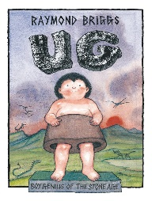

**Literacy**

The books we are covering are

**‘UG’ and ‘Moon Man’**

**The writing genres we are**

**covering are:**

* Description
* Diary
* Book review
* Newspaper report
* Narrative recount

**In addition children take part in:**

* Daily Guided Reading sessions
* Weekly comprehension lessons
* Daily grammar sessions
* Weekly spellings

**Numeracy**

**The topics we will be covering are:**

* Number sense and exploring calculation strategies
* Place value
* Graphs
* Addition and Subtraction



MC900212783[1]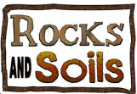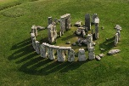

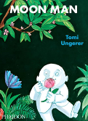

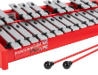

**Music**

**Stone Age**

Using the three periods of the 'Stone Age' as a stimulus, pupils learn to read, write and perform from western rhythm  
notation using 1, ½, 2 and 4 beat notes and the 1 beat rest.

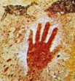

**Homework**

~Weekly spellings – test every **Friday**~ **~**Homework due back every **Wednesday**~

Please remember to read with your child at least three times a week and discuss what they are reading.

**PSHE**

**British values - Core Values**

**Religious Understanding – Get Up!**

Religious Understanding explores the Gospel story Jairus’ daughter in various creative and reflective ways. Through story and discussion, children will learn that they are designed for a purpose and how they should live in light of this.

**PE**

**PE kit must be worn to school every Wednesday**

**Golf** Children will explore and develop their accuracy of aiming at a target using a club over long and short distances.

**Fundamentals** Pupils will develop the fundamental skills of balancing, running, jumping, hopping and skipping. Pupils will develop their ability to change direction with balance and control.

**History**

**The Stone Age**

Children will explore how life changed for people during different periods of the Stone Age using archaeological evidence.

**Science**

**Rocks and Soils**

We will be learning to:

**Classify** and compare different kinds of rocks on the basis of their appearance and simple properties.

**Describe** how fossils are formed when things that have lived are trapped within rock.

**Recognise** that soils are made from rocks and organic matter.

**RE**

We will be learning about:

* **Homes**
* **Promises**

**Geography**

**Climate and weather**

We will be learning about weather, climate, climate zones, and biomes. We will identify the world’s hottest, coldest, wettest and driest locations.

**Computing**

**We are programmers**

Children will plan and create an algorithm for an animated scene in the form of a storyboard and then write a program in Scratch to create the animation.

**French**

**‘Getting to know you’ and ‘All about me’**

**Art and DT**

**Prehistoric Art**

We will be experimenting with charcoal, leaves and homemade paints to gain a sense of what it was like to create art thousands of years ago.

**Eating Seasonal**

We will learn about seasonal fruits and vegetables grow in different countries based on their climates. Design and make a tart.