Year 3 - Spring Curriculum Newsletter 2024

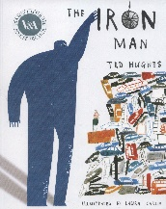

**Numeracy**

**The topics we will be covering are:**

* Daily times table practice
* Word problems
* Length
* Mass
* Volume
* Money
* Time

**Literacy**

The books we are covering is:

**The Iron Man and The Tin Forest**

**The writing genres we are**

**covering are:**

* diary entry
* persuasive letter
* description
* non-chronological report

**In addition children take part in:**

* Daily Guided Reading sessions
* Weekly comprehension lessons
* Daily grammar lessons
* Weekly spellings

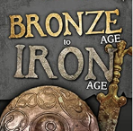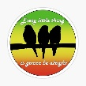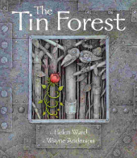MC900212783[1]

**History**

**Bronze Age to Iron Age**

* Improvements made in Bronze Age
* Improvements made in Iron Age
* Comparing Bronze Age and Iron Age

**PE**

**PE kit must be worn to school**

**every Thursday in Spring 1 (subject to change in Spring 2)**

* Fitness
* Ball skills

**PSHE**

* Diverse Britain
* Team

**ART**

* Elements of Art

Exploring two of the formal elements of art: shape and tone; finding shapes in everyday objects, draw accurately from observation; create form and shape using wire and practice shading neatly and from light to dark.

**Music**

* Three little Birds

Listen and appraise Reggae songs. Using

Three Little Birds to learn about pulse, rhythm, pitch, singing and playing instruments as well as learning to improvise and compose.

**Geography**

* Our world

**Science**

Magnets and forces

We will be learning about:

* Magnets
* Friction
* Forces

**RE**

We will be learning about:

* Journeys
* Listening and sharing
* Giving all

**Computing**

* We are who we are
* We are Co-authors

**Homework**

Weekly spellings – test every **Friday**

Homework due back every **Friday**

Please remember to read with your child at least three times a week and discuss what they are reading.