
Foundation - Spring Curriculum Newsletter 2023-2024
Literacy
Over this term we will look at these books;
Sharing a Shell

Rainbow Fish
Billy’s Bucket
Pirate Pete
What The Ladybird Heard At The
Seaside
Commotion In The Ocean (amongst others…)

Non-fiction texts & religious stories;

The Easter Story
We will be learning:
- set 1/2 sounds in phonics.
- to read and spell simple words and phrases using phonic knowledge.
- practising letter formation.
- to become more independent with our writing.
- set 1 sounds in phonics.
- to read and spell simple words using phonic knowledge.
- Writing our Christian names
- Practising letter formation.
Mathematics
- Number formation
- Addition and subtraction

- Counting to 20 and beyond.
- One to one correspondence counting with larger numbers
- Recite number names and order up to 20 and beyond.
- Number bonds to 10
- Comparing amounts
- 2D and 3D shapes





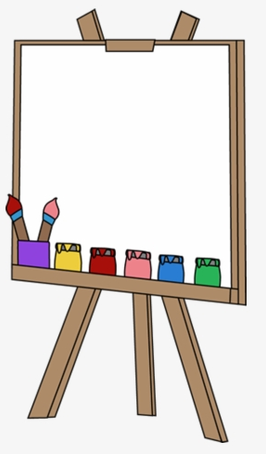
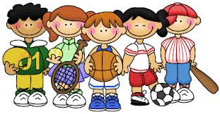
RE
We will be learning about: Galilee to Jerusalem

The Magi – Epiphany – (story) A Visit To The Temple – (Story) The Boy Jesus In The Temple – (Story) Jesus Blesses The Little Children – (Parable) Feeding the 5,000 – The Holy Trinity – The Glory Be – Catholic Social Teaching

Communication & Language
- Circle time activities to share our thoughts and opinions.
- Interaction in Role Play area.
- Speaking in complete sentences.
- Working in groups.
- Reading stories to widen our vocabulary.
- Learning how to speak to each other in a positive manner.
Expressive Arts & Design
- Using scissors correctly.
- Collage work and card making.
- Keeping to a steady beat.
- Moving in response to music.
- Drawing/painting simple representations of objects

Physical Development
PE kit must be worn to school every Tuesday
Gymnastics
Children explore basic movements, creating shapes, balances, and jumps and begin to develop rocking and rolling. They show an awareness of space and how to use it safely and perform basic skills on both floor and apparatus.
Games
Children will practise and further develop fundamental movement skills through games. They will also learn how to score and play by the rules, how to work with a partner and begin to understand what a team is, as well as learning how to behave when winning and losing.

PSED
(Personal, Social & Emotional Development)
Being a Good Friend:
- What does sharing mean?
- What makes a good friend?
- Saying kind things to others
Behaviour:
- To continue to form good relationships with adults and peers.
- Responding to significant experiences, showing a range of feelings where appropriate.
- Consider the consequences of their words and actions, for themselves and others.
- To understand what is right and wrong and why.

Understanding the World

We will be looking at;
Sharks
Global warming
Under the sea
Different areas around the globe

We will also look at:
Chinese New Year
How/what sinks or floats

