
Year 3 - Autumn 1 Curriculum Newsletter 2023

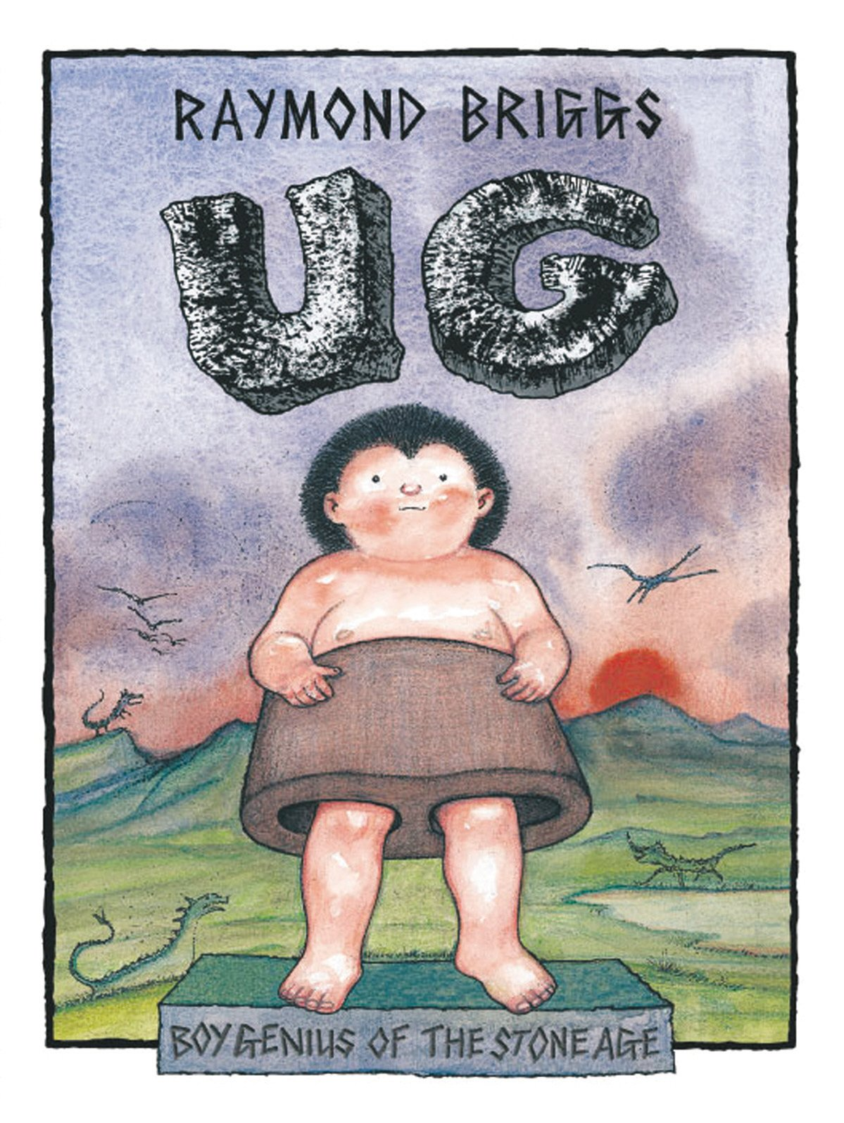
Literacy
The book we are covering is:
UG

The writing genres we are
covering are:
- Description
- Diary
- Book review
In addition children take part in:
- Daily Guided Reading sessions
- Weekly comprehension lessons
- Daily grammar lessons
- Weekly spellings
Numeracy
The topics we will be
covering are:
- Place value
- Addition
- Subtraction

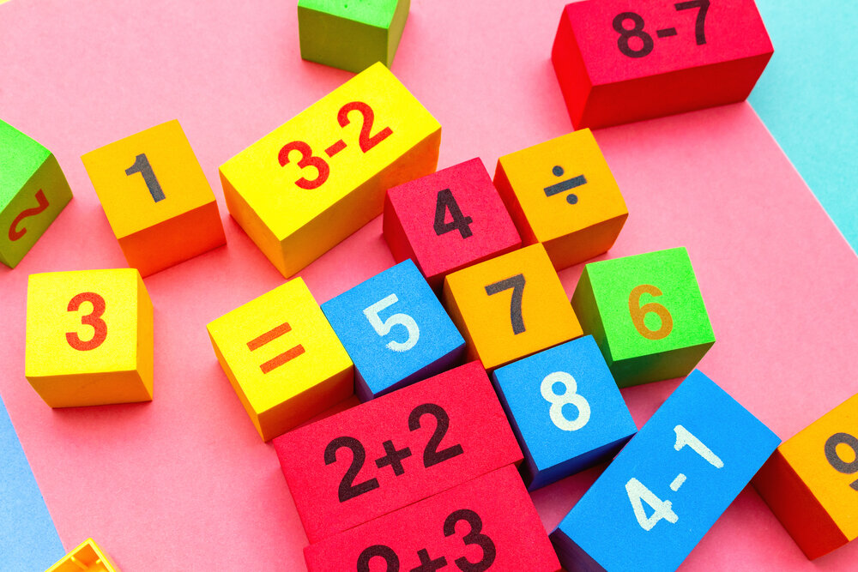
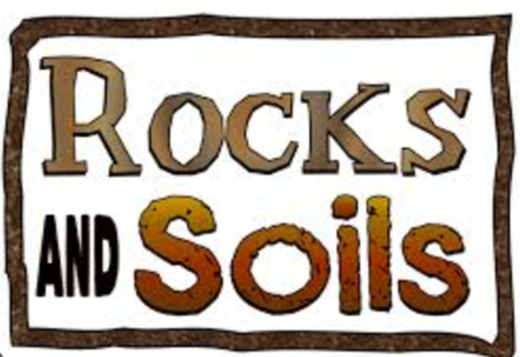
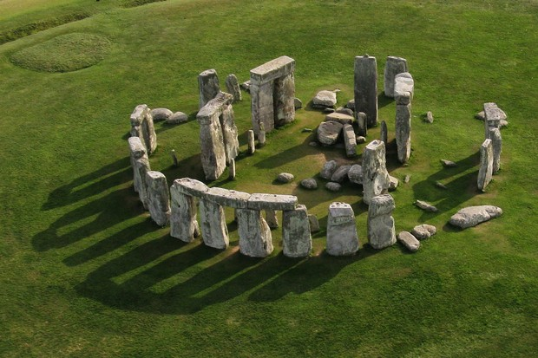
RE
We will be learning about:

- Homes
- Promises

Homework
~Weekly spellings – test every Friday~ ~Homework due back every Friday~
Please remember to read with your child at least three times a week and discuss what they are reading.

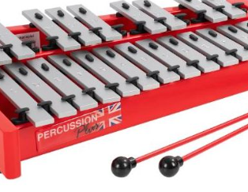
Music
Glockenspiel
The learning is focused around exploring and developing playing skills through the glockenspiel.


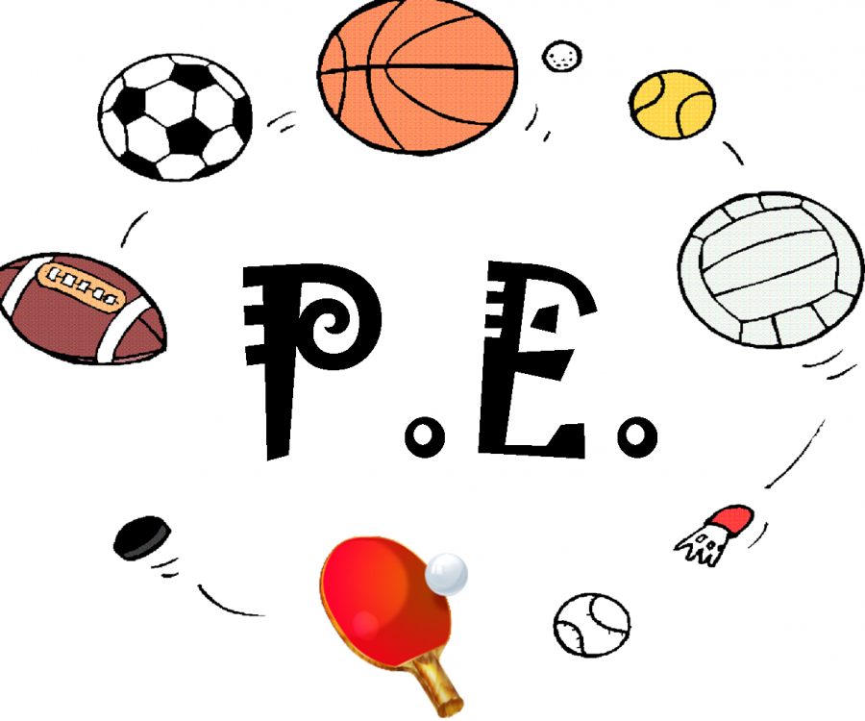

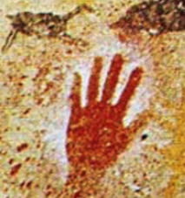
History
The Stone Age
Children will explore how life changed for people during different periods of the Stone Age using archaeological evidence.
Science
Rocks and Soils
We will be learning to:
Classify and compare different kinds of rocks on the basis of their appearance and simple properties.
Describe how fossils are formed when things that have lived are trapped within rock.
Recognise that soils are made from rocks and organic matter.

PE
PE kit must be worn to school every Tuesday
Golf
Children will explore and develop their accuracy of aiming at a target using a club over long and short distances. They will have opportunities to apply their skills in a range of challenges working individually and with others.

PSHE/Wellbeing
~British values ~Aim High~ Core Values
Children will focus on
- Achievements and the attitude that helps us to achieve
- Aspirations, opportunities and personal goals
- Preferred learning styles
- Challenges people face and barriers to success and strategies to overcome obstacles
Computing
We are programmers
Children will plan and create an algorithm for an animated scene in the form of a storyboard and then write a program in Scratch to create the animation.
Art and DT
Prehistoric Art
We will be experimenting with charcoal, leaves and homemade paints to gain a sense of what it was like to create art thousands of years ago.
Eating Seasonal
We will learn about seasonal fruits and vegetables grow in different countries based on their climates. Design and make a tart.
Geography
Climate and weather
We will be learning about weather, climate, climate zones, and biomes. We will identify the world’s hottest, coldest, wettest and driest locations.
French
Getting to know you and all about me

